Market Basket Analysis Using Apriori Algorithm

1. Introduction
Market Basket Analysis is a data analysis technique used to identify products that customers frequently purchase together. Businesses use this technique to understand customer buying behavior and improve sales through better product placement, promotions, and inventory management.
In this project, a grocery store transaction dataset was analyzed to discover relationships between products purchased by customers. The Apriori Algorithm was used to identify frequent itemsets and generate association rules.

2. Objective
The main objectives of this project are:
- To identify products that are frequently purchased by customers.
- To discover relationships between products bought together.
- To understand customer purchasing patterns.
- To provide business recommendations based on the analysis.

3. Dataset Description
The dataset contains grocery store transaction records.
Dataset Information:
- Total Records: 38,765
- Total Transactions: 14,963
- Unique Products: 167
The dataset contains the following columns:
1. Member Number – Unique customer identifier.
2. Date – Date of transaction.
3. Item Description – Product purchased by the customer.
Each transaction may contain one or more products purchased by a customer on a particular date.

4. Tools and Technologies Used
The following tools and libraries were used in this project:
- Python
- Jupyter Notebook
- Pandas
- NumPy
- Matplotlib
- Mlxtend Library
These tools were used for data cleaning, data transformation, visualization, and association rule mining.

5. Methodology
Step 1: Data Loading
The grocery transaction dataset was loaded into Python using Pandas.
Step 2: Data Preparation
The data was organized into transactions by grouping products purchased by the same customer on the same date.
Example:
Transaction 1:
- Whole Milk
- Bread
- Yogurt
Transaction 2:
- Soda
- Bottled Water
Step 3: Transaction Encoding
The transaction data was converted into a basket format using TransactionEncoder.
In this format:
- True = Product present in transaction
- False = Product not present in transaction
This format is required for the Apriori Algorithm.
Step 4: Frequent Itemset Generation
The Apriori Algorithm was applied to identify products that frequently appear together in customer transactions.
Step 5: Association Rule Generation
Association rules were generated using support, confidence, and lift metrics to identify relationships between products.

6. Key Findings
The analysis identified the following most purchased products:
1. Whole Milk
2. Other Vegetables
3. Rolls/Buns
4. Soda
5. Yogurt
The visualization showed that Whole Milk is the most frequently purchased product among all products in the dataset.
Several association rules were also identified, indicating that customers who purchase certain products are more likely to purchase Whole Milk in the same transaction.
Examples:
- Customers buying Bottled Beer often purchase Whole Milk.
- Customers buying Brown Bread often purchase Whole Milk.
- Customers buying Bottled Water may also purchase Whole Milk.
These patterns indicate opportunities for cross-selling and product bundling.

7. Visualization
A bar chart was created to display the Top 10 Most Purchased Products.
The chart clearly shows product popularity and helps businesses understand customer demand patterns.
Whole Milk had the highest purchase frequency, followed by Other Vegetables and Rolls/Buns.

8. Business Recommendations
Based on the analysis, the following recommendations are suggested:

1. Product Placement Optimization
Products frequently purchased together should be placed near each other in stores.
Example:
- Whole Milk near Bread and Yogurt sections.

2. Bundle Offers
Create promotional bundles for products commonly purchased together.
Example:
- Whole Milk + Bread Combo
- Yogurt + Soda Discount Offer

3. Cross-Selling Strategies
Recommend related products during checkout to increase sales.

4. Inventory Planning
Maintain sufficient stock of highly demanded products such as Whole Milk and Other Vegetables.

5. Targeted Promotions
Use purchase patterns to create personalized offers and improve customer engagement.

9. Benefits of Market Basket Analysis
Market Basket Analysis provides several business benefits:
- Better understanding of customer behavior.
- Improved product placement.
- Increased sales through cross-selling.
- Better inventory management.
- More effective marketing campaigns.

10. Conclusion
This project successfully applied Market Basket Analysis using the Apriori Algorithm to identify customer purchasing patterns in grocery store transactions.
The analysis revealed that Whole Milk is the most frequently purchased product and is strongly associated with several other products. These insights can help businesses improve product placement, promotional strategies, and inventory management.
Overall, Market Basket Analysis is a valuable technique for understanding customer behavior and making data-driven business decisions.

Top 10 Products chart :
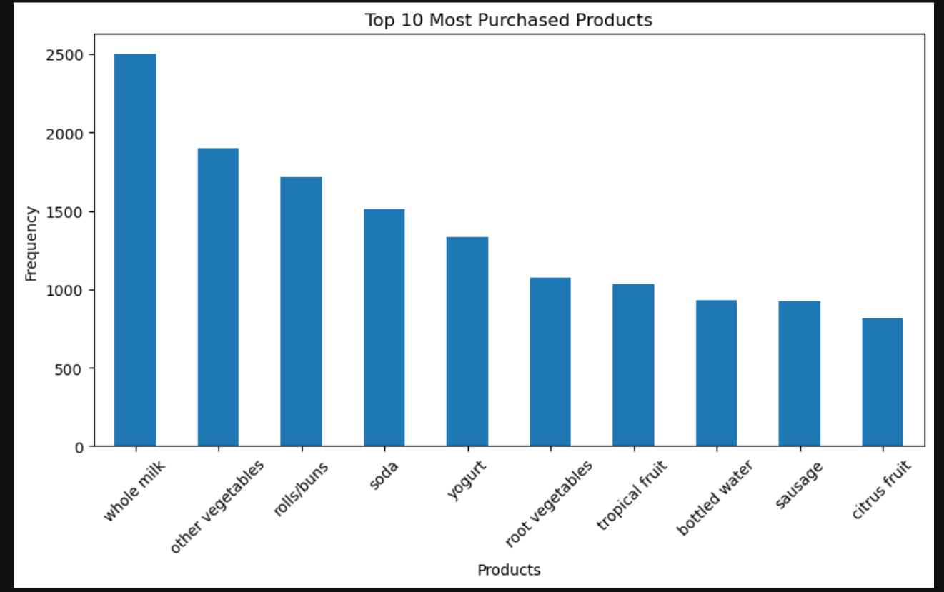
GitHub Repository Link :
https://github.com/Rutwikgidde/Business-Analysis-Internship

